Name:_________________________________________________ Pd:______________ Date:________
Quiz 3 – Projectile Motion – Multiple Choice (10 pt) **MAKE-UP**
Use the diagram below to help you answer questions 1 – 5. It represents a ball throw from a rooftop with a velocity (v) at an angle (θ) and landing on the ground (ignore air resistance). A, B, C, & D represent positions of the ball while it is a projectile (after release and before impact).
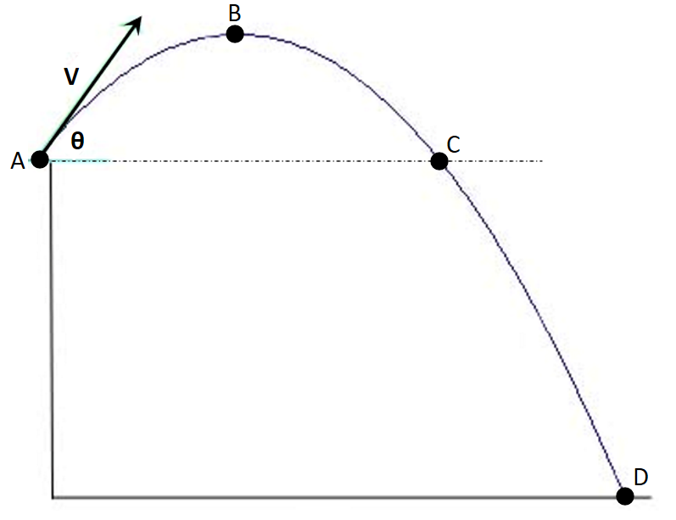

______ 1. Which of the following vectors best represents the ball’s velocity at point C?

a) b) c) d)

______ 2. Which of the following vectors best represents the ball’s acceleration at point B?

a) b) c) d)

______ 3. What is the initial velocity in the vertical direction?

a) 0 m/s b) $v∙sinϴ$ c) $v∙cosϴ$ d) 9.8 m/s

______ 4. Where is the ball moving the slowest?

a) Point A b) Point B c) Point C d) Point D

______ 5. Which of the following statements is TRUE?

a) The time to Point C must be exactly half of the time to Point D.
b) The final velocity at Point D is 0 m/s.
c) The ball’s speed at Point D is the same as the speed at Point A.
d) The ball will strike the ground at an angle greater than it was launched.
e) The velocity at Point B is 0 m/s.

______ 6. While riding at a constant speed on a train at Kiddle Park, Victor Velocity playfully tossed Fluffy straight upward. During the time Fluffy was in the air, the train moved forward one meter. Assuming no air resistance, Fluffy landed…
a) in Victor’s loving arms
b) one meter in front of Victor
c) one meter behind Victor
d) several meters behind Victor

______ 7. Which of the following statements is true when an object is launched with equal speeds at angles of 20° and 70° to the horizontal on level ground with no air resistance?
a) The time of flight is the same.
b) The maximum height the ball will reach is the same.
c) The horizontal velocities are the same.
d) The horizontal distance traveled is the same.

______ 8. An arrow is shot from the ground on a level surface. The vertical distance the arrow travels in the air will be maximized when shot at what angle ϴ?

a) 0° b) 30° c) 45° d) 60° e) 90°

______ 9. A basketball player makes a 3-point basket. What is true about the flight of the ball from release to basket (assuming it was released below the level of the basket with no air resistance)?
a) At its peak, the ball has been in the air for more than half of its total flight time.
b) The ball is traveling at its fastest speed when it reaches its maximum height.
c) The ball will enter the basket at greater angle than it was released by the shooter.
d) The release speed is less than the speed the ball is traveling when it enters the basket.

______ 10. For the basketball shot in #9…when determining the time the ball will take to get to the basket, which of the following would you expect in your calculations:
a) Two calculated times…one positive and one negative…use the positive one.
b) Two calculated times…one zero and one positive…use the non-zero answer.
c) Two calculated positive times…use the smaller one.
d) Two calculated positive times…use the larger one.

